Start the splunk   
sudo /opt/splunk/bin/splunk start

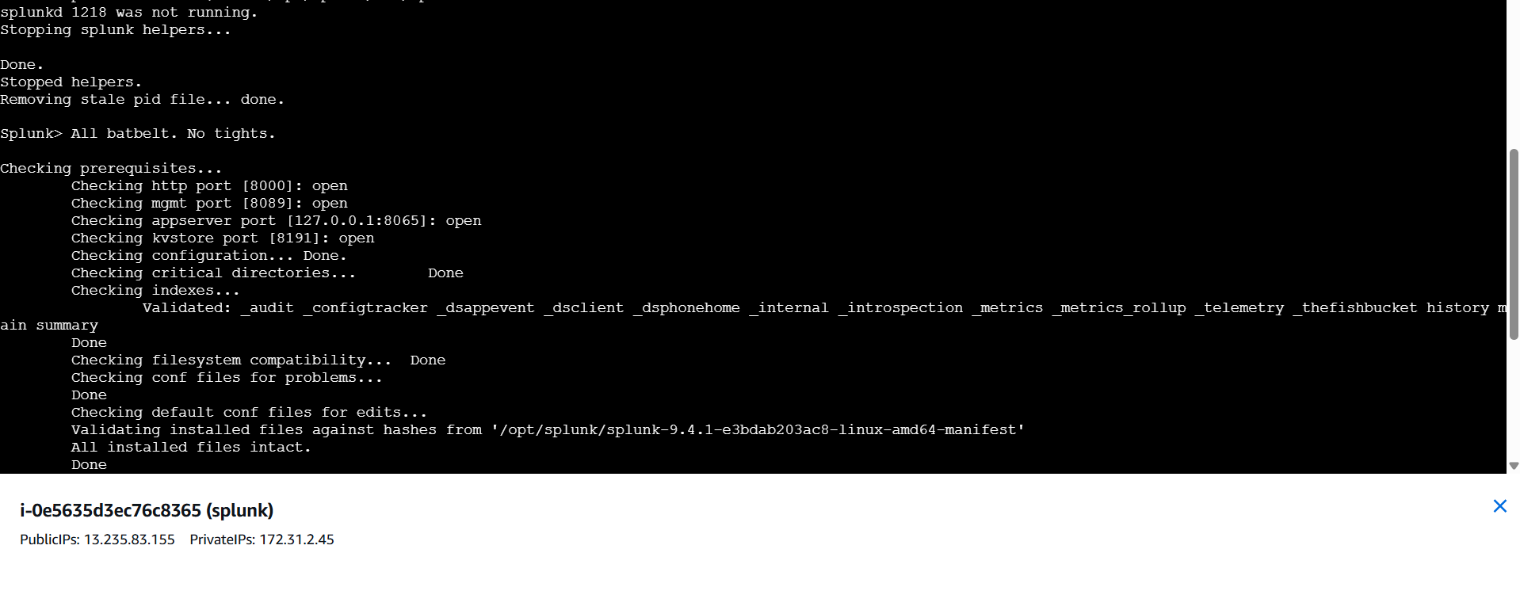

Open splunk dashboard   
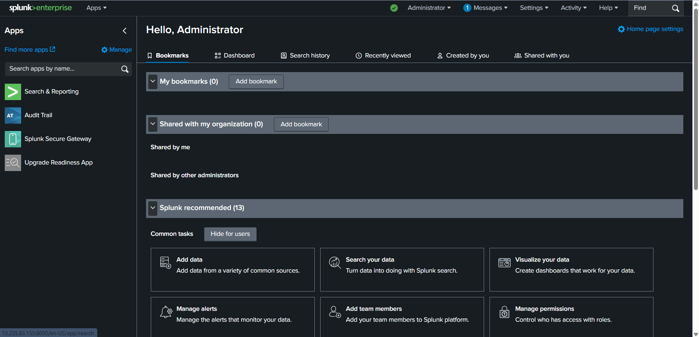

Click on settings – ADD data  
get data from from chatgpt of log csv file  
  
chatgpt prompt: i need log csv file to upload in splunk and download

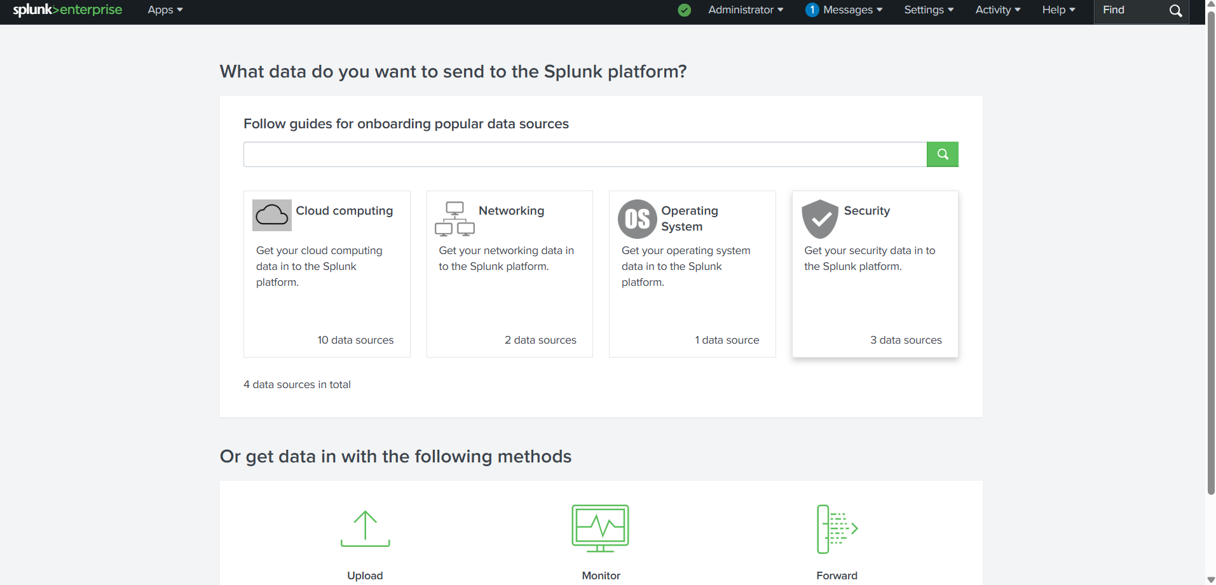

Click on upload

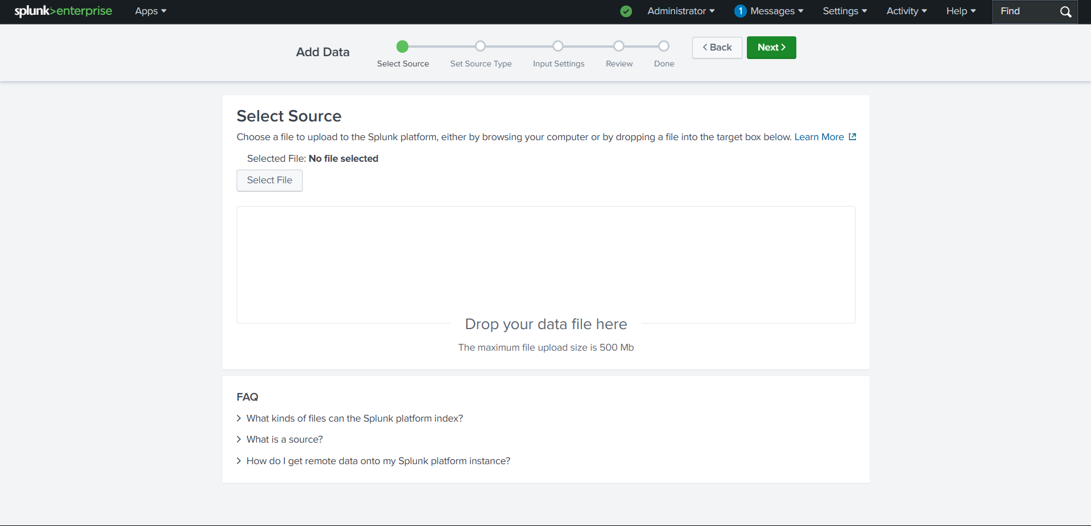

Select from your computer

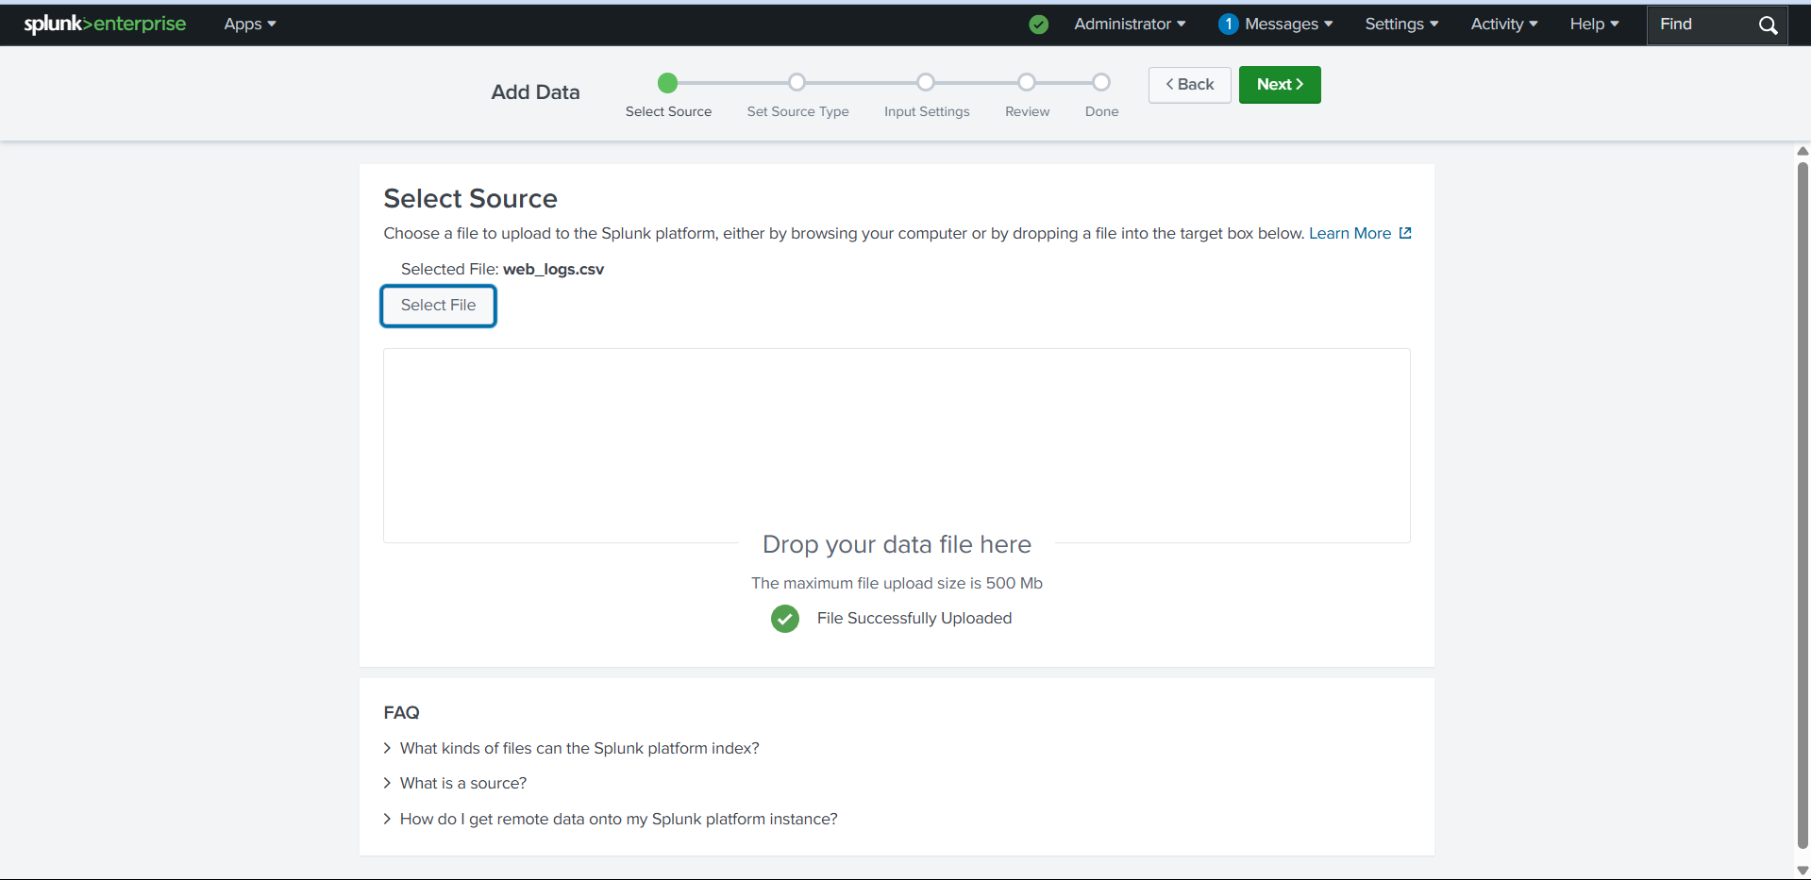

Source type is automatically detected  
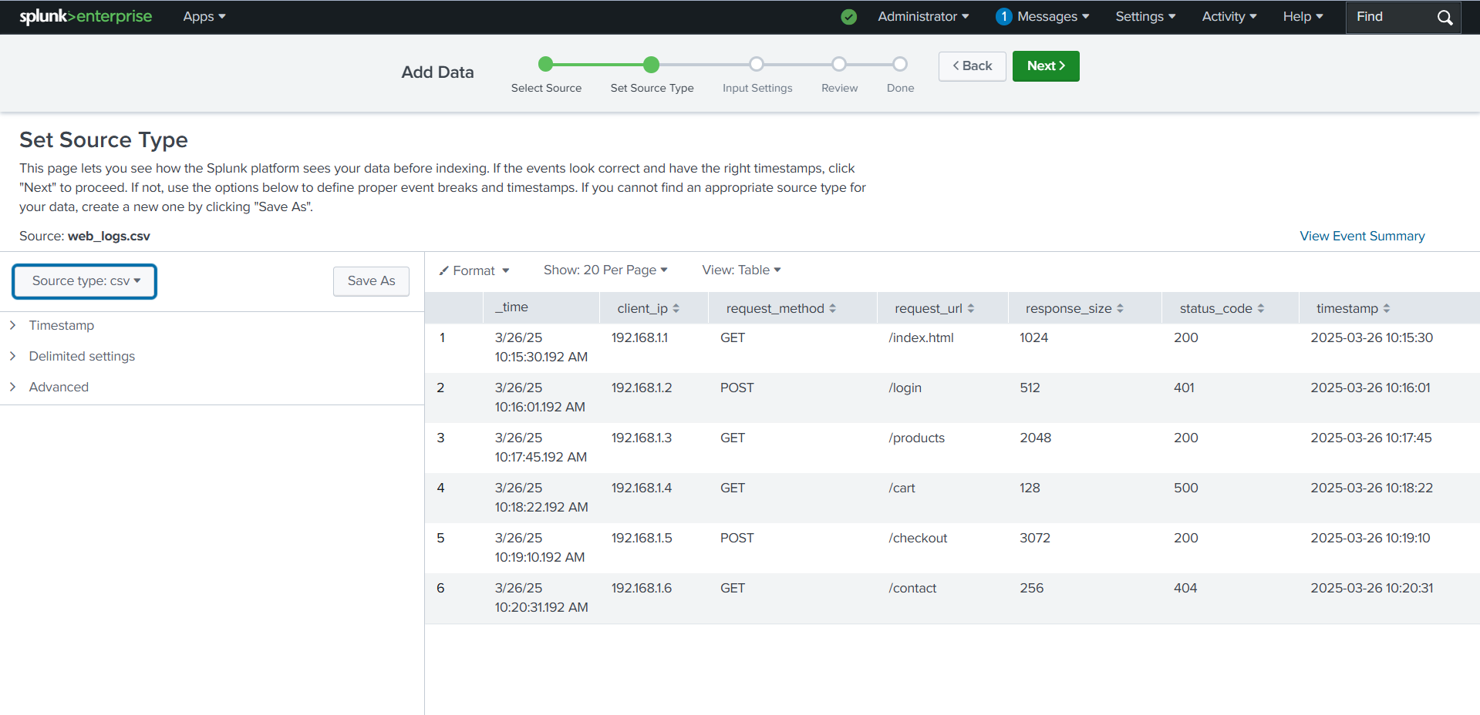

Click on next

Paste your public ip in host  
change index default to main  
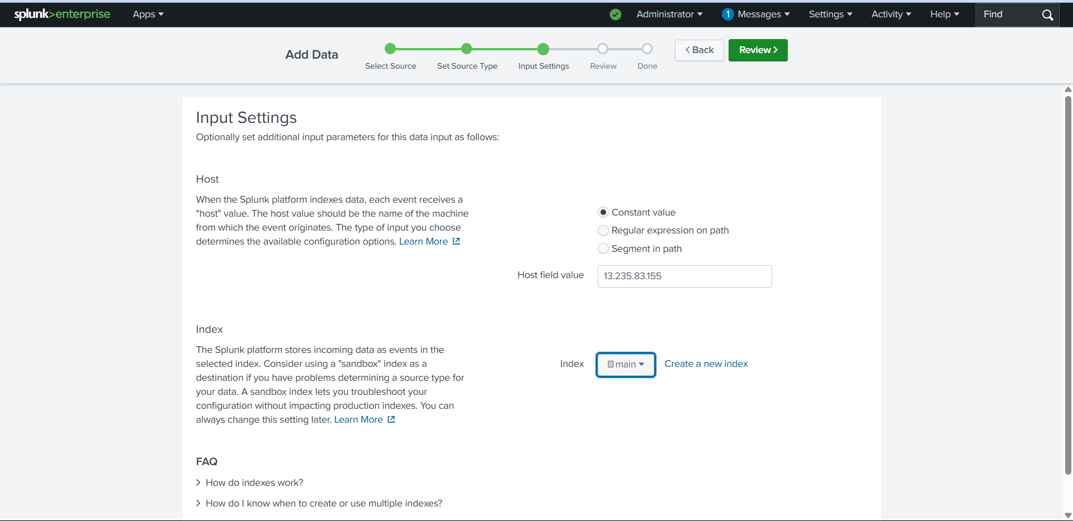

Click on review  
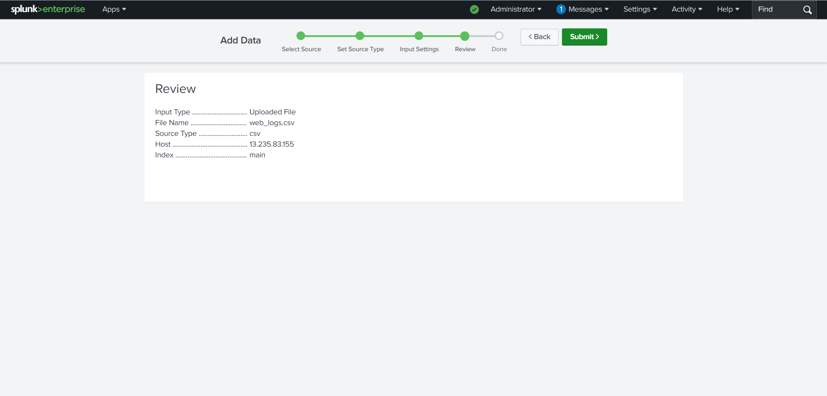

Click on submit and click on start search   
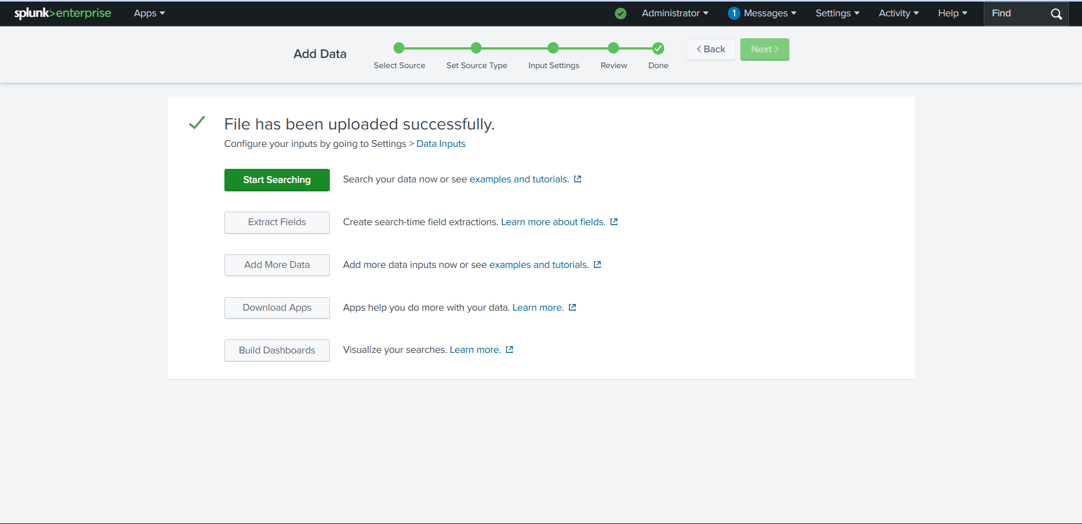

Serach below the command on serach bar

index="main" host="52.66.252.215"

| table timestamp, client_ip, request_method, request_url, status_code, response_size

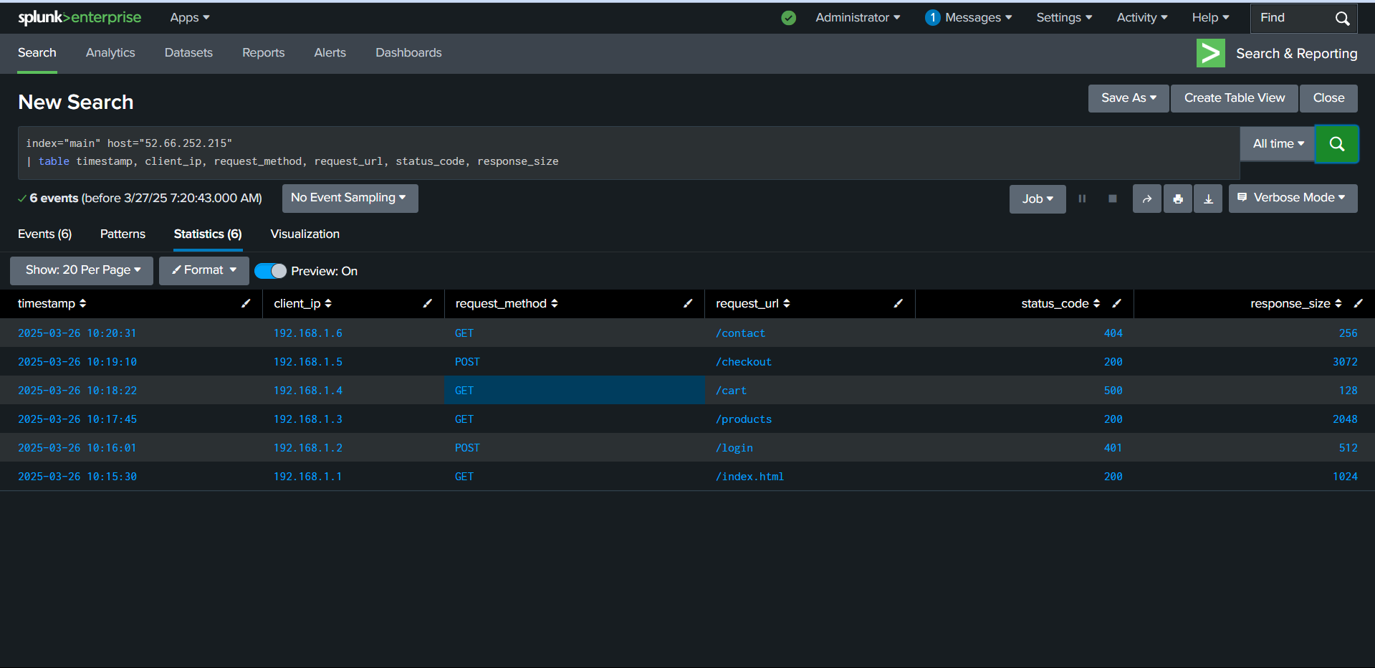

Go to visualization we can have multiple charts

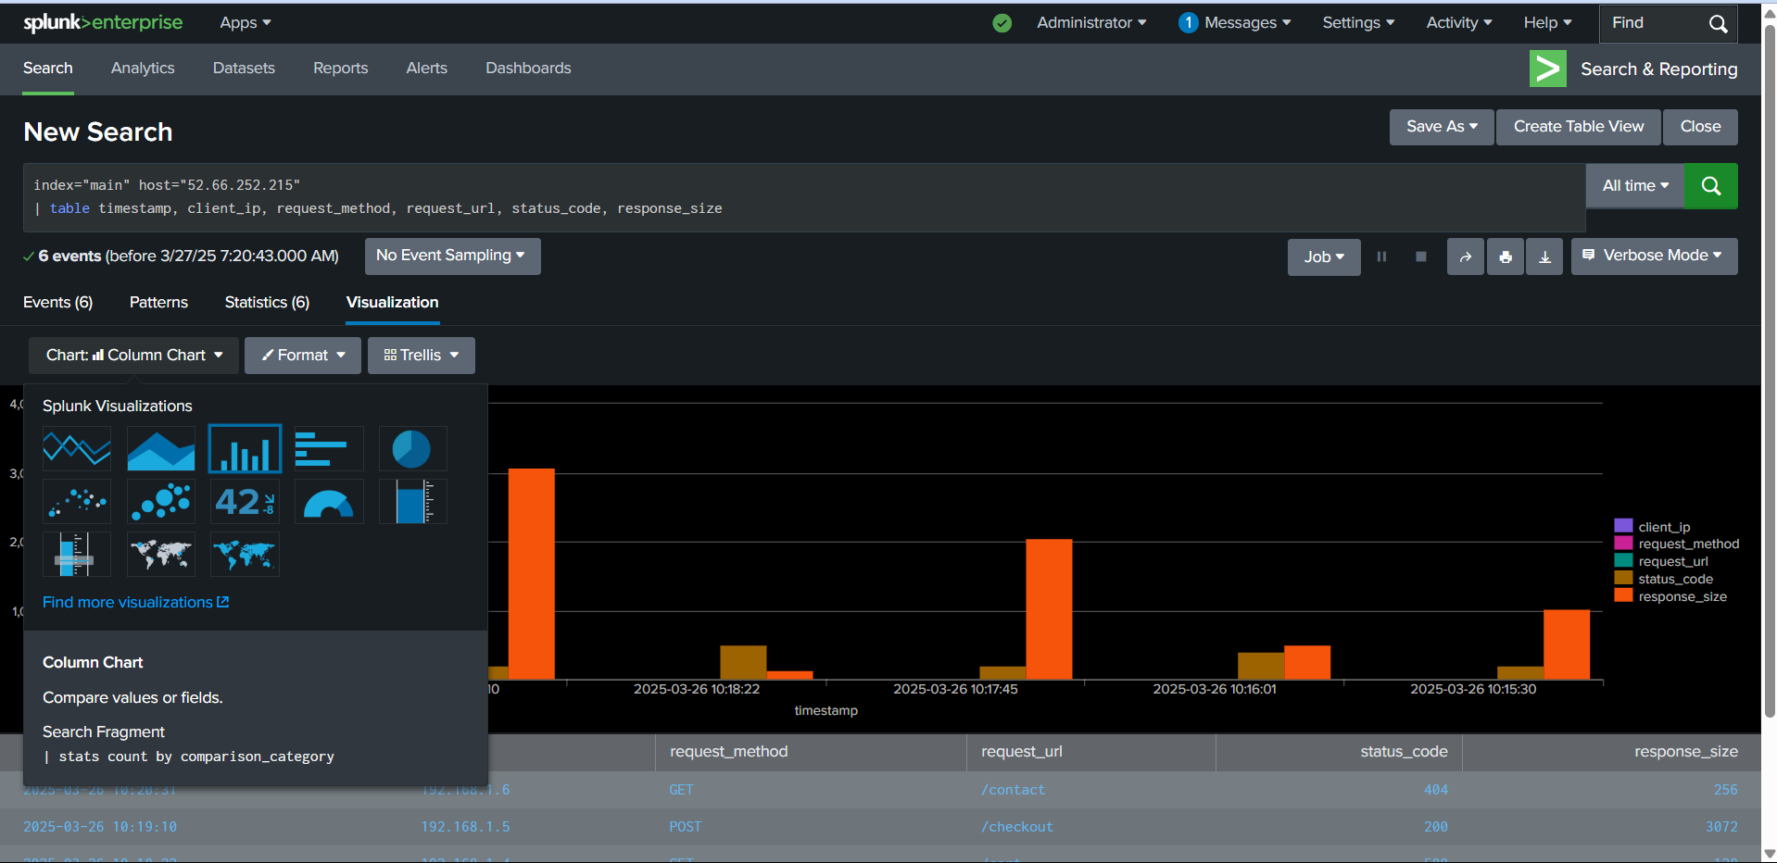

Click on save as new dashboard  
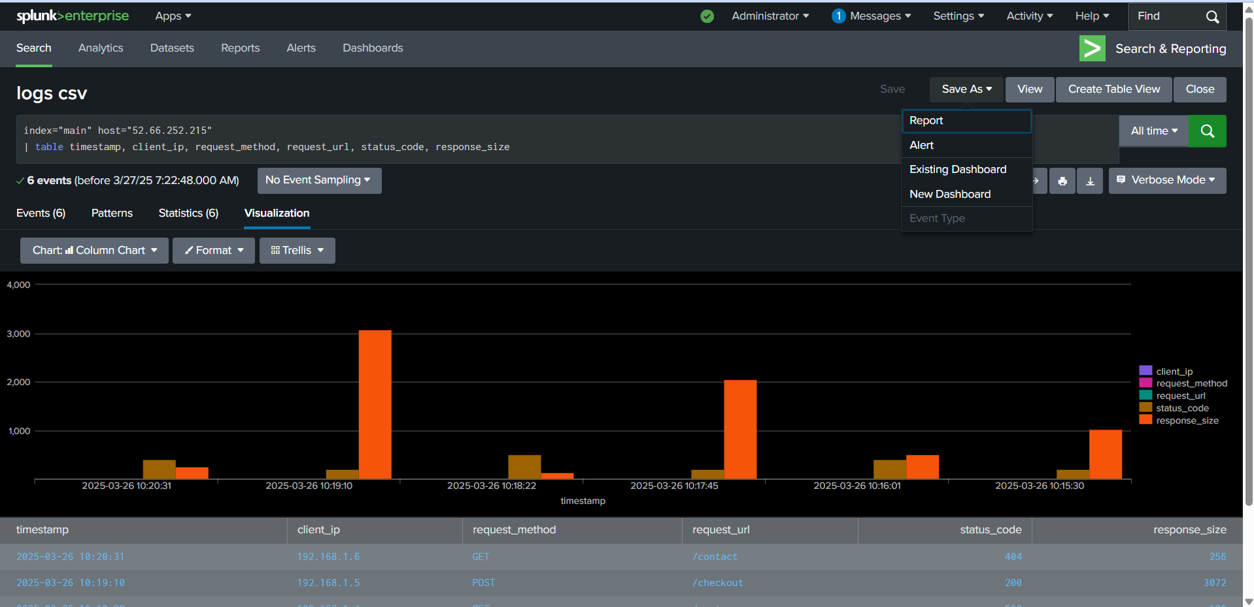

Give details to create to dashboard and click on dashboard studio and grid   
